Practice Activity: Create a Flyer in Microsoft Word

Before You Begin
✅ Download all attached files.
✅ Save the files in your Office Fund folder before starting.

Purpose
In this activity, you will create a flyer for a volunteer opportunity at New Brunswick Community College.
You will practice:

- Adding text
- Inserting pictures
- Formatting text
- Working with text boxes
- Creating a footer
- Saving and organizing files

Step 1: Open and Save Your Document
- Open Microsoft Word.
- Select Blank Document.
- Select File > Save As.
- Click Browse.
- Open your Office Fund folder.
- Save your file as: FirstnameL_Word1
Example: AynslieC_Word1

Step 2: Turn On Helpful Tools
Show Formatting Marks
- Select the Home tab.
- In the Paragraph group, click the Show/Hide (¶) button.
Tip: This is a toggle button.
- Click once = ON
- Click again = OFF
Show the Ruler
- Select the View tab.
- In the Show group, check the Ruler box.

Step 3: Insert Text from a File
- Select the Insert tab.
- In the Text group, click the ▼ beside Object .
- Select Text from File.
- Find the file: Word_Practice1_StartFile
- Select the file.
- Click Insert.
The text will be added automatically.

Step 4: Insert Additional Text from a File
- Place the cursor at the end of the paragraph starting with: "This Fall..."
- Press the Spacebar once.
- Select the Insert tab.
- In the Text group, click the ▼ beside Object .
- Select Text from File.
- Find the file: Word_Practice1_Copy
- Select the file.
- Click Insert.
The text will be added automatically to this location.

Step 5: Format the Text
Format All Text
- Select all text in the document.
- Select the Home tab
- In the Font group
- Select Font and set: Calibri
- Select Font Size and set: 12
Format the Title
- Select only the title.
- Select the Home tab
- In the Font group
- Change:
  - Font Size: 36
  - Font Color: Turquoise, Accent 4
- In Paragraph group
- Change
  - Alignment: Center
Apply Text Effects
- In the Font group
- Select Text Effects and Typography
- Outline: Turquoise, Accent 4, Darker 50%
- Hover over Shadow and select Shadow Options
  - From Presets, select Outer: Offset Right
  - From Color, select Turquoise, Accent 4, Darker 50%

Step 6: Insert a Picture
- Place the cursor at the beginning of the paragraph starting with: "This Fall..."
- Select Insert tab
- In the Illustrations group, click the ▼ under Pictures
- Select This Device.
- Find the file: Word_Practice1_Picture
- Select the image
- Insert the picture.

Step 7: Format the Picture
Apply Text Wrapping
- Select the picture. A new tab appears.
- Select Picture Format tab
- In the Arrange group
- Click the ▼ beside Wrap Text.
- Select Square.
Resize the Picture
- Select the picture.
- In the Size group
- Change the width to: 4”
Position the Picture
- In the Arrange group
- Click the ▼ beside Wrap Text.
- Select More Layout Options.
- In the Position tab:
  - Horizontal Alignment: Left and Relative To: Margin
  - Vertical Alignment: Top and Relative To: Line
- Click OK.
Add Effects
- In the Picture Styles group
- Click the ▼ beside Quick Styles
- Select Drop Shadow Rectangle
- In the Adjust group
- Click the ▼ beside Artistic Effects
- Select Pastels Smooth
Save Your Work
- Select the File tab
- Click the Save.
- Compare your document to the image below.
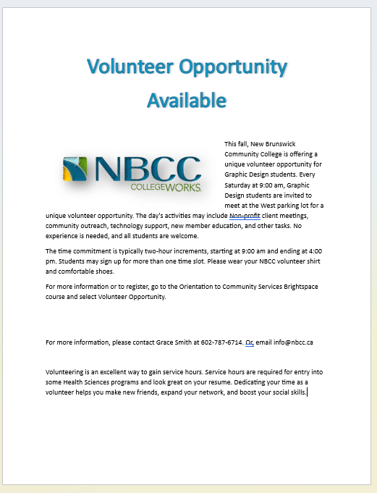

Step 8: Add a Page Border
- Select the Design tab.
- In the Page Background group
- Select Page Borders.
- Choose:
- Select Setting and set: Shadow
- Select Style and set: Triple Lines
- Select Color and set: Turquoise, Accent 4
- Select Apply To and set: Whole Document

Step 9: Create a Contact Information Box
- Place your cursor below the title.
- Press Enter six times.
- Select the Insert tab
- In the Illustrations group
- Click the ▼ beside Shapes
- Select Rectangle: Rounded Corners
- Draw a rectangle near the left margin.
Set the Shape Size
- A new tab appears.
- Select Shape Format
- In the Size group, change
- Height: 1"
- Width: 6.4"
Add Text
- Select: For more information, please contact Grace Smith at 602-787-6714. Or, email info@nbcc.ca
- Select the Home tab
- In the Clipboard group, select Cut (scissor icon)
- Double-click the shape to show the cursor
- Right-click and select Paste
Format the Text
- Select the text
- Select the Home tab
- In the Font group change the
- Font: Calibri
- Size: 16
- Style: Italicized
- Color: White
Format the Shape
- Select Shape Format tab
- In the Shape Style group
- Select the ▼ beside Shape Fill
  - Select Turquoise, Accent 4
- Select the ▼ beside Shape Outline
  - Select Turquoise, Accent 4 Darker 50%
- Select the ▼ beside Shape Outline
  - Hover over Weight and select: 3 pt
- Move the shape to sit slightly below the title
- Remove extra Paragraph Marks

Step 10: Create a Text Box
- Press: Ctrl + End to move to the end of the document.
- Ensure the cursor is positioned under the last paragraph
- Select the Insert tab
- In the Text group
- Select the ▼ under Text Box
- Choose the first text box option.
Set the Text Box Size
- A new tab appears.
- Select Shape Format
- In the Size group, change
- Height: 1"
- Width: 4.5"
Add This Text
- Select: Volunteering is an excellent way to gain service hours. Service hours are required for entry into some Graphic programs and look great on your resume. Dedicating your time as a volunteer helps you make new friends, expand your network, and boost your social skills.
- Select the Home tab
- In the Clipboard group, select Cut (scissor icon)
- Click in the Textbox
- Right-click and select Paste
Resize the Text Box
- Click on the bottom-middle handle (small circle)
- Drag down until all text is visible
Move the Text Box
- Hover over the border of the text box until a double arrow cross appears
- Drag the text box below the last paragraph on the first page.
Set the Position
- Select Shape Format
- In the Arrange group
- Click the ▼ beside Wrap Text.
- Select More Layout Options.
- In the Position tab:
  - Horizontal Alignment: Centered and Relative To: Margin
  - Vertical Absolute Position: 0.25" and Below Paragraph
- Click OK.
Format the Text Box
- In the Shape Style group
- Click the ▼ beside Quick Styles
- Select Colored Outline, Turquoise Accent 4
- Click the ▼ beside Shape Effect
- Hover over Shadow
- Select Outer Offset Center Shadow
Format the Text Inside the Box
- Select the text inside the text box
- On the Home tab
- In the Font group
- Change the style to Italics
- In the Paragraph group
- Change the alignment to Center
Save Your Work
- Select the File tab
- Click the Save.
- Compare your document to the image below.
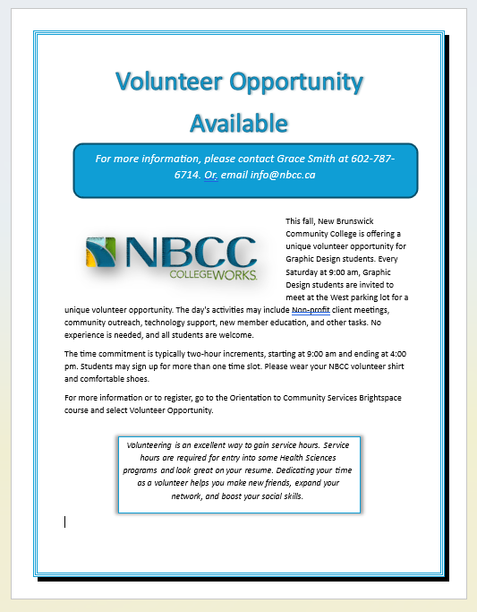

Step 11: Add a Footer
- Select the Insert tab
- In the Header & Footer group
- Select the ▼ under Footer
- Select Edit Footer.
Insert the File Name
- In the Inset group
- Select the ▼ under Document Info
- Select File Name field.
⚠️ Do not type the file name manually. Use the Document Info feature.

Step 12: Final Check
- Turn off formatting marks.
- Compare your flyer with the example provided by your instructor (Scroll down).
- Make any corrections needed.
- Use Zoom (bottom-right corner of Word) to view your work more clearly.
- Save your document again.
- Upload your completed Word document to the correct assignment folder in Brightspace.
- 